A Road Map to History Happened Here
For Museums, Historical Sites, Libraries, and Archives

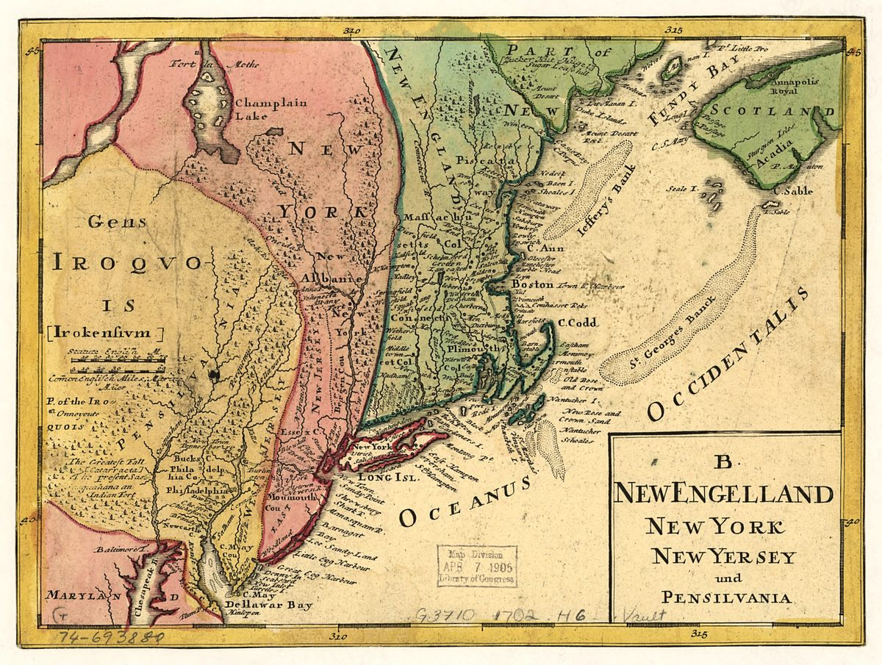
Revolution NJ is making programming directed towards K-12 classrooms a priority in its planning on the road to the 250th Anniversary of the founding of the United States. We are encouraging deeper and wider connections between our students, educators, communities, and public history sites. To that end, we have developed a special program called History Happened Here, which will connect students grade 5-12 with public history sites to conduct local research, creating a project based on the following prompt:

Our country’s revolutionary founding ideals included liberty, equality, justice, self-determination, and the pursuit of happiness. Engaging with these subjects has been at times challenging, inspirational, and even contentious. Focusing on an individual, group, location, or event at any point in our nation’s history, examine how your local community has dealt with one or more of these revolutionary ideals.
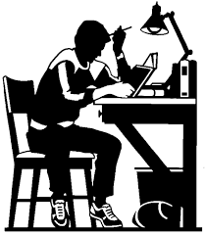
Our goal is to help students engage in the historical process, drawing lessons from the past to apply to the present and future. Students are free to explore any aspect of New Jersey’s past (not merely the founding). As a consequence, all public history sites will be potentially relevant for our students. Helping students with research requires a different set of requirements than those that were addressed in the April 2020 site readiness report. This document provides some suggestions to continue the journey that began surveying public history sites in 2019 and 2020, and the Perfect Partners webinar series, which helped connect educators to public history sites.

A site visit will be a requirement for students participating in History Happened Here, and we want to make sure you are ready and equipped to work with young people with limited to no experience doing research. The program will encourage students throughout the state to engage in the authentic use of public history materials while visiting historic sites to make history come alive for them as they experience a sense of place that they could not get solely through electronic means.
Here are some guidelines and expectations for participating sites. In order to be prepared for the program, you ideally should have:

- familiarity with the HHH prompt;
- an understanding of the New Jersey Learning Standards and how they are used by educators;
- identified relevant individuals, places, and events you have resources for, offering suggestions for educators and students;
- regular hours on weekends or weekday afternoons after 3pm;
- staff knowledgeable about the content and resources available on site; and
- digital access to your collections, as students are unlikely to make multiple visits.

Sites that want to maximize their public profile in conjunction with History Happened Here should further consider:

- having staff available to make presentations to educators or students in person on site, in local schools, or via video conferences; and
- creating a short informational video (3 to 5 minutes) highlighting your holdings and providing visuals of the site.

The official program will run in the 2025-2026 school year, giving your organization the lead time necessary to meet as many of the above goals as possible.

Many students working digitally will be inclined to cut and paste documents with plans to peruse the materials later, while those working with non-digital materials will frequently want to take photos of everything rather than take the time to carefully read, record accurate sourcing information, and take notes. Please do your part to help students follow the appropriate research protocols in order to promote responsible scholarship.

While we encourage sites to offer potential suggestions to those students who request ideas, we ask that student curiosity ultimately drive the research subject matter. With a modicum of assistance, they will find something they are passionate about.

Together we can help our young people embrace the enduring value and relevance of history. We look forward to your participation in History Happened Here!

Grants are available from the New Jersey Historical Commission that can be utilized for digitization.
Revolution NJ will be creating videos for 21 public history sites. Those that aren’t selected for the video project are provided these guidelines to produce their own videos for inclusion on our resources page.

